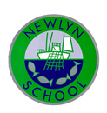

We have loved welcoming your child to Newlyn School and beginning their school journey with them. The children have all settled into school amazingly well and are learning to follow the rules and routines of the classroom. They have been very busy learning about how school works and what is expected of them each day. Please can you ensure you child brings their water bottle, book bag and a waterproof coat with them everyday, thank you

**Foundation Class Newsletter!**

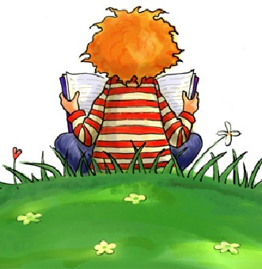

All of the children have now been given a reading book and we are so pleased to see you have been recording in your child’s reading record when they have read - thank you. Reading books will be changed twice a week – please feel free to share home books with your child and make a comment in their reading record.

Reading is the single most important thing you can do to support your child’s education. Please aim to read **everyday** for 10 minutes with your child.

Tapestry Learning Journal

Your children’s online learning journals are all active now. Thank you for your comments we hope you enjoy seeing what your children are busy learning about in school.

‘All About Me Bag’

Thank you so much for sending in your child with their ‘Me Bags’ this week. The children did a great job sharing them with the class and it was so lovely to find out a little bit more about your child.

Parent Meetings

We have arranged for parent meetings to take place on Wednesday 13th October. Mrs Richards will be in touch to arrange a time that is convenient with you to meet with us. This will be a chance to discuss how your child is settling in and for you to ask us any questions you may have. We look forward to seeing you.

**The Foundation Class team**

Miss Tonkin, Mrs Holden & Mrs Oliver



We will be starting to get changed for PE lessons from Tuesday 9th November so can you ensure your child has their PE kit on their peg in a separate PE bag. Your child will need a green t-shirt, black shorts and plimsolls/trainers.