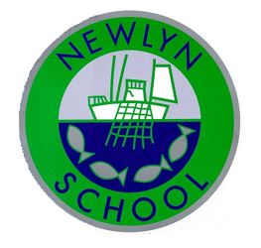
Newlyn School

Intimate Care Plan

Personal and Family Details
Parental consent
Named Child

Name of child (full): D.O.B.

Class / Teacher name: __________________________
Contact details Priority 2
Name :
Relationship to child :
Phone number 1 :
Phone number 2 :
Contact details Priority 1
Name :
Relationship to child :
Phone number 1 :
Phone number 2 :

Medical diagnosis / condition:

Nature of Personal Care:

All school staff trained in intimate / personal care have responsibility to carry out toileting and personal care duties in our school and apply suncream
Parents/Carers have responsibility to provide:
Change of underwear, Nappies, Wipes , Plastic back to return items home
Additional information from parents/carers:
Please identify any birthmarks / moles / blemishes or any other condition / important information that adults should be made aware of

Procedure A (Include, what will be carried out, how and by whom)
Procedure B (Include, what will be carried out, how and by whom)

Please see Newlyn School Personal/Intimate Care and Toileting Policy which can found on our website: https://www.newlynschool.co.uk

If you require a paper copy of the policy please let us know.

I / We give permission for the named member (s) of staff to attend the care needs of my/ our child and agree with the procedures proposed.

Signed by: |  | Relationship to child : | Parent / guardian / carer | Date:
Signed by: |  | Relationship to child : | Class / tutor teacher | Date:
Signed by: |  | Relationship to child : | SENDCo | Date:

Personal /Intimate Care and Toileting Log

DATE | TIME | TYPE OF CARE  (toileting, nappy changed, washed, other personal/intimate care task) | CARRIED OUT BY | SIGNATURE

