Simple ‘How to’ Guide – Social Stories
Introduction
Social Stories™ are short descriptions of specific events or problems that support autistic people to navigate and understand situations. They were originally created by Carol Gray in 1991.

They present information in a neutral, visual way that does not change and can be kept by the learner for future reference.

Social Stories can be used in a variety of circumstances, to support with:
- Preparing for non-routine or unexpected events;
- Developing an understanding of social communication and behaviours;
- Developing independence and self-advocacy skills;
- Sequencing, planning, and organising;
- Helping others to understand an autistic person’s perspective and experience.
Strategies
Social Stories should follow a clear structure:

Guidelines for writing Social Stories:
- Make sure that the story has a clear purpose or goal. However, the goal should not be to teach compliance or ‘control’ the cyp and their emotional or sensory responses to a situation; it should be supportive and provide options for how to best navigate a situation;
- Keep the language neutral, supportive, and simple;
- Ensure that the content and presentation are appropriate to the age, interests, attention span, and understanding of the cyp;
- A Social Story should use descriptive sentences (which provide context) and coaching sentences (which gently guide behaviour or give options e.g. ‘I will try to…’, ‘When I feel overwhelmed I can…’, ‘It’s ok to…’). They should not include demands or rules (e.g. ‘I must…’, ‘I have to…’, ‘I need to…’).
- Don’t tell the child how they will or should feel about the situation;
- Don’t say that something definitely ‘will’ happen if there is a chance it might not. Instead, use words like ‘sometimes’, or ‘if…’.
- Where appropriate, try to write the Social Story collaboratively with the cyp.

Guidelines for using Social Stories:
- Plan when, how often, and where you will share the Social Story with the cyp; it is likely a Social Story will have to be read a number of times before the information is processed and embedded;
- Social Stories were designed to be used before a tricky situation arises, not to debrief afterwards. However, it is ok to use a Social Story to reinforce what options and accommodations are available to the cyp in situations that they regularly find challenging;
- Present it at a time when everyone is calm and able to focus;
- Make sure that the cyp has their own copy, stored somewhere accessible and safe;
- Only run one Social Story at a time;
- Monitor and review its impact over time.
Resources and Links
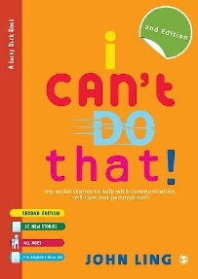
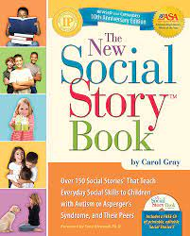

Social Story Sampler - Carol Gray - Social Stories (carolgraysocialstories.com)

Social stories and comic strip conversations (autism.org.uk)

The STARS Team is committed to promoting the difference not deficit approach to understanding and celebrating autism. As part of this commitment, we encourage the use of neuro-affirmative language. This refers to language that aims to promote positive understanding and responses to autistic people. This commitment is inspired by neurodivergent individuals and neurodivergent led groups, who emphasise the harm deficit-based language does to them.

